**B2C Delegated User Administration Sample Cod Pre-requisites**

The B2C Delegated User Administration sample application has several pre-requisites that must be configured prior to its use including:

1. An application registration in the Azure AD blade of your B2C tenant that will be used to facilitate the authentication integration between Azure AD tenants and your Azure AD B2C tenant. Follow the steps in this document <https://docs.microsoft.com/en-us/azure/active-directory-b2c/identity-provider-azure-ad-multi-tenant-custom>.
2. An application registration in the Azure AD blade of your B2C tenant that will be used to access the Azure AD Graph API in order to perform user administration operations on users in your B2C tenant. Make sure to create a client secret for this registration as the application leverages the client credential flow. Also, make sure to set the API permissions as shown below and make sure an admin consents to these permissions for the organization.

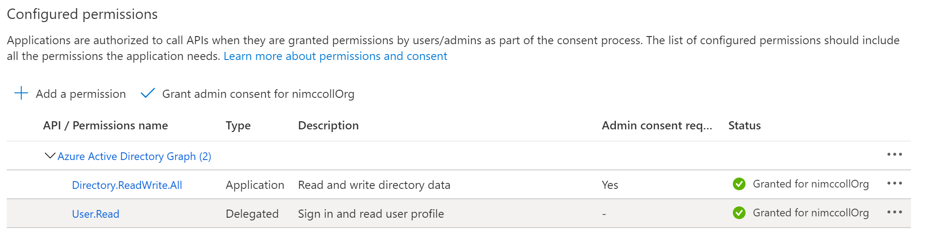

1. An application registration in the B2C blade of your B2C tenant for the delegated user administration application. This will allow users to login to the B2C delegated user administration application.
2. Two custom user attributes must be added to the B2C user profile as follows:
   1. Organization (string – identifies the user’s organization)
   2. UserRole (string – identifies the user’s level of access in the B2C delegated user administration application)
3. An Azure Search Index with the following schema. This will allow the B2C delegated user administration application to retrieve user’s by Organization since the Graph API does not support filtering by custom attributes.

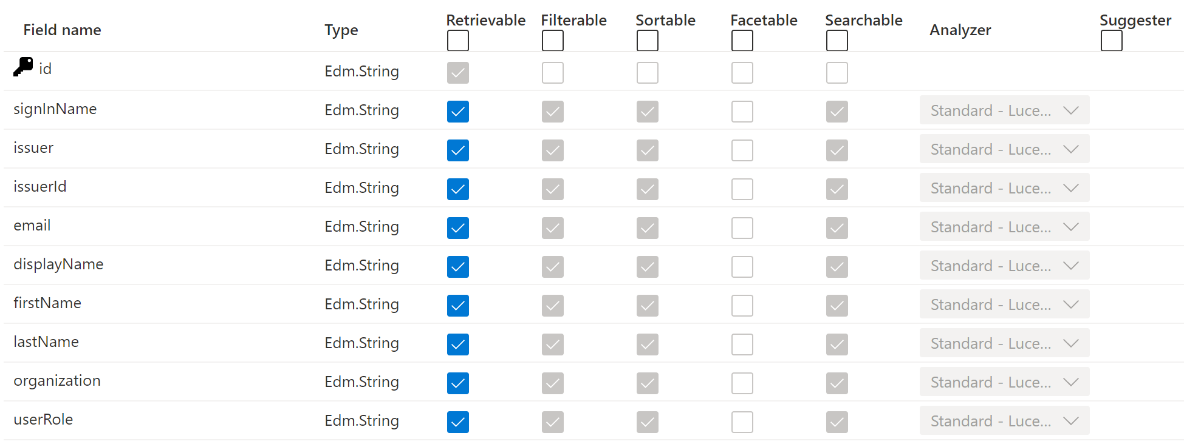

1. In the Azure AD blade of your B2C tenant retrieve the Application (Client) ID and the Object ID of the application named “b2c-extensions-app”. This information will be needed to retrieve the custom attributes of the user from the Graph API.
2. Follow the steps in this tutorial <https://docs.microsoft.com/en-us/azure/active-directory-b2c/custom-policy-get-started> to prepare your B2C tenant to support the creation of custom policies using the Identity Experience Framework.
3. Once you have completed these steps you need to update the following files in the sample code.
   1. Web.config (AADB2C.UserAdmin)
      1. Populate all of the B2C tenant name values with your tenant name.
      2. Populate the b2c:ClientId and b2c:ClientSecret with the values from step 2.
      3. Populate the ida:ClientId with the value from step 3.
      4. Populate the AZURE_SEARCH values with the information from index created in step 5.
   2. App.config (AADB2C.UserMigration)
      1. Populate all of the B2C tenant name values with your tenant name.
      2. Populate the b2c:ClientId and b2c:ClientSecret with the values from step 2.
      3. Populate the AZURE_SEARCH values with the information from index created in step 5.
   3. GraphAccountModel (AADB2C.GraphService)
      1. Populate the value of _extensionApplicationId with the client ID from step 6. Remove all of the hyphens from the value.
   4. GraphAccountsModel (AADB2C.GraphService)
      1. Populate the value of _extensionApplicationId with the client ID from step 6. Remove all of the hyphens from the value.
   5. All XML files contained in the SocialAndLocalAccounts folder.
      1. Populate all of the B2C tenant name values with your tenant name.
   6. B2C_1A_UA_TrustFrameworkExtenions.xml (SocialAndLocalAccounts)
      1. Update the IdentityExperienceFramework client ID and ProxyIdentityExperienceFramework client ID values from the information obtained in step 7.
      2. Update the Azure AD B2C Integration App ID with the client ID value from step 1.
      3. Update the list of allowed Azure AD tenants with a comma separated list of allowed tenants in the form <https://sts.windows.net/tenant-GUID>.
      4. Update the B2C Extensions App ID and B2C Extensions Object ID with the values from step 6.

Once these steps have been completed you should be able to deploy and execute the B2C Delegated User Administration application to create an manage users in your Azure AD B2C tenant.